Practice Questions

**Question 1.**

Create a application that will ask the user for a letter and checks if its a vowel or a consonant.

**Example:**

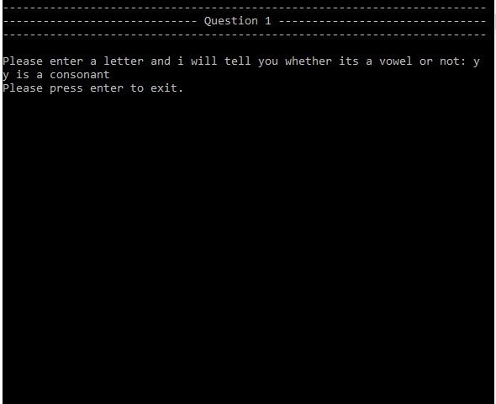

I'm lost, can you show me...

**Question 2.**

Body Mass Index (BMI) is a measure of body fat based on height of adults. It provides an indication of whether a person is underweight, overweight or a healthy weight for their height.

Body Mass Index is calculated using the following formula:

**BMI = Weight / (height * height) =>where weight is in Kg's and height is in Meters**

Write a program that prompts the user for the weight (kilograms) and the height (centimetres) and outputs their BMI.

**Example:**

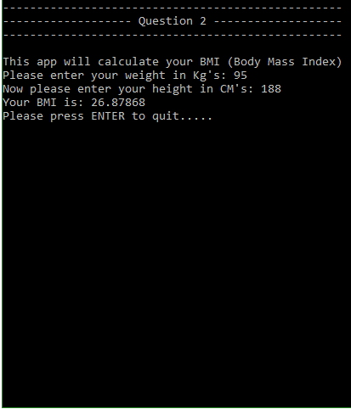

I'm lost, can you show me...

**Question 3.**

Create a application that uses a for loop that will loop 20 times. Each loop the app needs to ask the user for a whole number. After the loop the app needs to add all of the numbers together and display the sum of all 20 numbers.

**Example:**

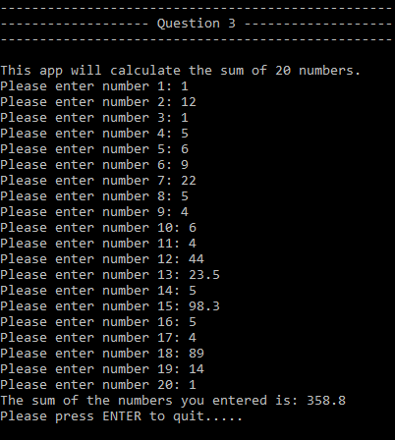

I'm lost, can you show me...

**Question 4.**

Make an application that uses a while loop that can find the factorial of 10. ie 1*2*3*4*5....etc

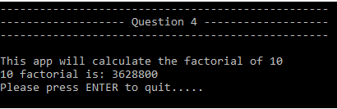

I'm lost, can you show me...

**Extension.**

* Is it possible to make an application that could solve a quadratic equation in any of its' forms. Remember that we are only dealing with x2 at the moment(Ax2 + Bx + C = 0 for example) and would it be easier to solve in another form.
* How would i deal with a number that is positive or negative and how would i represent that in my application.